What will we be learning?  Capacitance  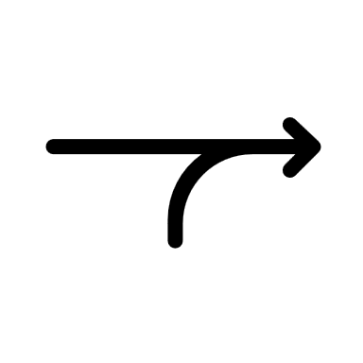 | Why this? Why now?  Previous Learning  Charge and current, Energy, power and resistance, Electrical Circuits, Stars, Cosmology, Newton’s Laws of Motion and Momentum, Gravitational Fields  Future Learning  Electric Fields, Magnetic Fields.  Enquiry Processes  Identify Variables, Collect Data, Present Data, Analyse Patterns, Manipulate Equations, Draw Conclusions, Justify opinions and conclusions. | Key Words:  Capacitor  Capacitance  Dielectric  Farad  Exponential decay  Logarithms  Time constant  Smoothing
What will we learn?
Charging and discharging of capacitors in terms of the flow of electrons
The unit of the Farad
Calculating capacitance in series and parallel
Investigation of circuits containing capacitors
P.D. – charge graphs for capacitors
Energy stored by capacitors
Charging a capacitor through a resistor
Applying capacitance equations for charging and discharging
Misconceptions in this topic
- The abbreviation for Capacitance is C which can be confused with charge which is Q
- The units for capacitance are Farads (F) but the units for Coulombs (charge) are C!!
What opportunities are there for wider study?
Careers – Electrical Engineer, Electronic Engineer, Aviation, Defence Specialist, Astrophysicist, Theoretical Physicist, Space Engineer, Rocket Scientist, Astronaut, Satellite Designer.
STE(A)M – For details of courses and opportunities look at:
https://highcliffe.sharepoint.com/sites/LearnSTEM
How will I be assessed?
End of Topic Assessment, A2 Paper Assessments

